**PART A**

**EXPERIMENT NO. 5**

**A.1 Aim: - Build a Prototype of your Enterprise System**

**A.2 Theory**

**What is a prototype and why do you need one?**

In software development, a **prototype** is an early design of the product with which users can interact. Prototypes are not coded but visualized using specific tools to click between screens and mimic the final user experience. Prototyping allows you to save time and money on development as you can uncover usability problems early on and polish the design before building the product.

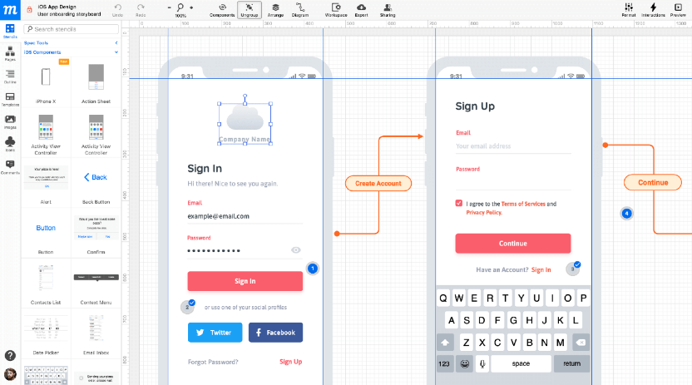

**Wireframes** are outlines of the design, showcasing the location of content, buttons, text, etc. They can be hand drawn or created using special tools. A wireframe represents the basic skeleton of UI without getting into details but allowing designers to quickly edit the elements and their positions. They are the first step in the design process after gathering information and are usually created by the UX team.

## Prototyping approaches

Just like with software, you can go differently about building a prototype. Here are a few techniques and when they can be beneficial.

### **Rapid throwaway prototyping**

As the name suggests, throwaway prototyping means that such a prototype will only be relevant for a short time, for example, for one sprint. During that time, it will go through a few cycles of modification and testing, but will eventually be discarded. Paper prototypes are by definition “throwaways” because after everyone is satisfied with it, a new prototype will be built. Throwaway prototypes are helpful to gather initial user feedback, which then is used to create an actual working prototype.

### **Evolutionary prototyping**

This method is the closest to how prototyping is generally approached. After building a prototype, you present it to the users and gather feedback. Then, you introduce refinements based on that feedback and show the prototype to the users once more. You do it several times until the prototype is fully accepted by users. This way, the prototype evolves toward its final version. This approach ensures that the final product will likely meet user requirements since they actively participated in the process.

### **Incremental prototyping**

Often used for large, enterprise products, incremental prototyping involves breaking the product into several smaller pieces and preparing prototypes for them individually. Each prototype is separately tested and refined before being merged into a whole prototype. To make sure that different pieces fit together in terms of look and feel, you need to prepare a style guide in advance. This technique significantly reduced the prototyping time, since you work on different parts of the system in parallel.

### **Extreme prototyping**

Extreme prototyping is used specifically in web development and it’s divided into three stages, according to the three layers of the web app:

1. Building static wireframes in HTML for the presentation layer.
2. Transform HTML wireframes into a functional prototype by connecting them to simulated services.
3. Implement the services into the final prototype.

Extreme prototyping allows you to demonstrate the prototype to users at every level. Don’t be too caught up with the classification, but rather use those approaches to your advantage. Below we will describe the main steps that go into prototyping, regardless of the method.

## Stages of prototyping

Prototype creation is a design task, so you may approach it like any other designing project, from gathering information on what needs to be in a design to testing how well you interpreted user requirements with a finished design. Keep reading for more details and tips.

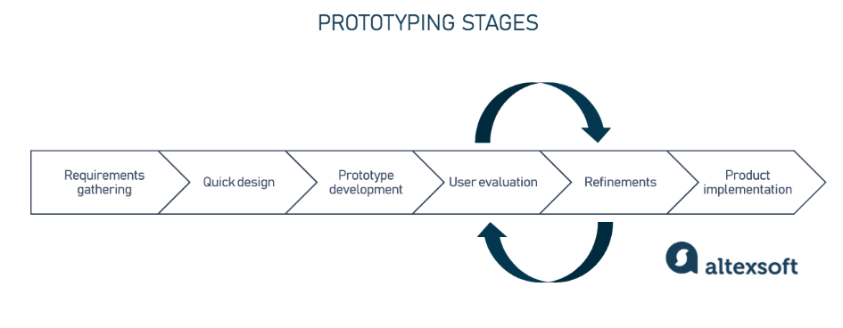

**A.3. Task:**

**Build a prototype for your enterprise system.**

At least make 3-4 interfaces including the home page. You just build a rapid prototype using software’s like Figma, Canva or wireframe sketcher or and other software you are comfortable with. Paste the screenshots of the pages in word file to be submitted for the experiment. You can also add the mobile view of your system.

**PART B**

(PART B: TO BE COMPLETED BY STUDENTS)

*(Students must submit the soft copy as per the following segments within two hours of the practicals. The soft copy must be uploaded on Blackboard LMS or emailed to the concerned Lab in charge Faculties at the end of practical; in case Blackboard is not accessible)*

|  |  |
| --- | --- |
| Roll No: A016 A038 | Name: Varun K, Yashasvi T |
| Class: Btech CsBs 4th Year | Batch: 1 |
| Date of Experiment: 17-02-2023 | Date of Submission: 17-02-2023 |
| Grade: |  |

**B.1 Build a prototype for your enterprise system.**

At least make 3-4 interfaces including the home page. You just build a rapid prototype using software’s like Figma, Canva or wireframe sketcher or and other software you are comfortable with. Paste the screenshots of the pages in word file to be submitted for the experiment. You can also add the mobile view of your system.

### Website Mode

 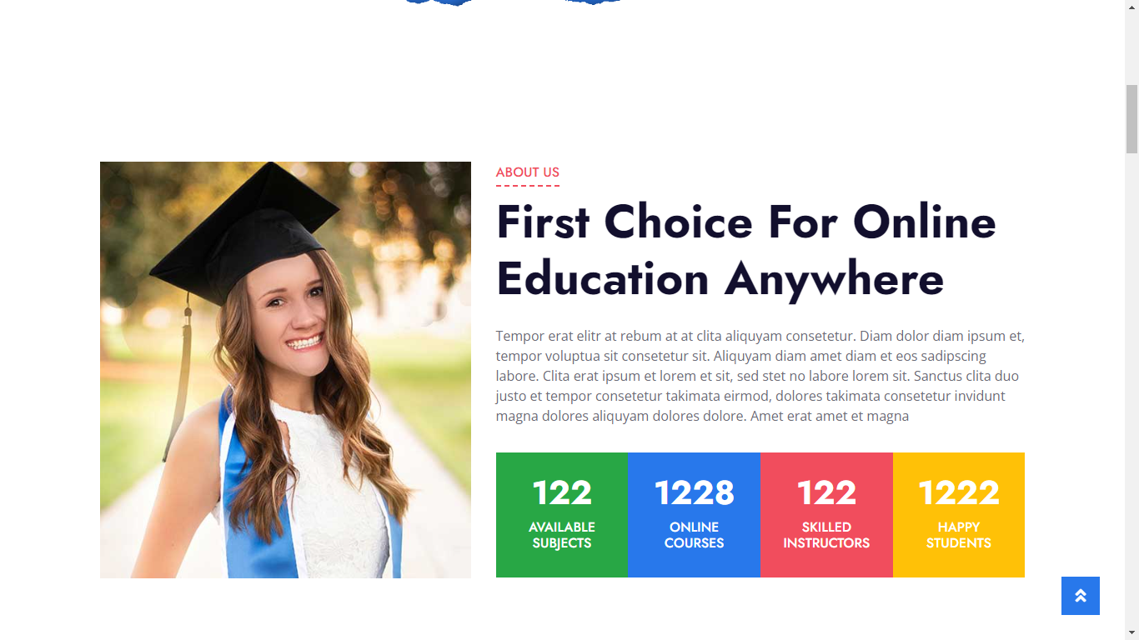 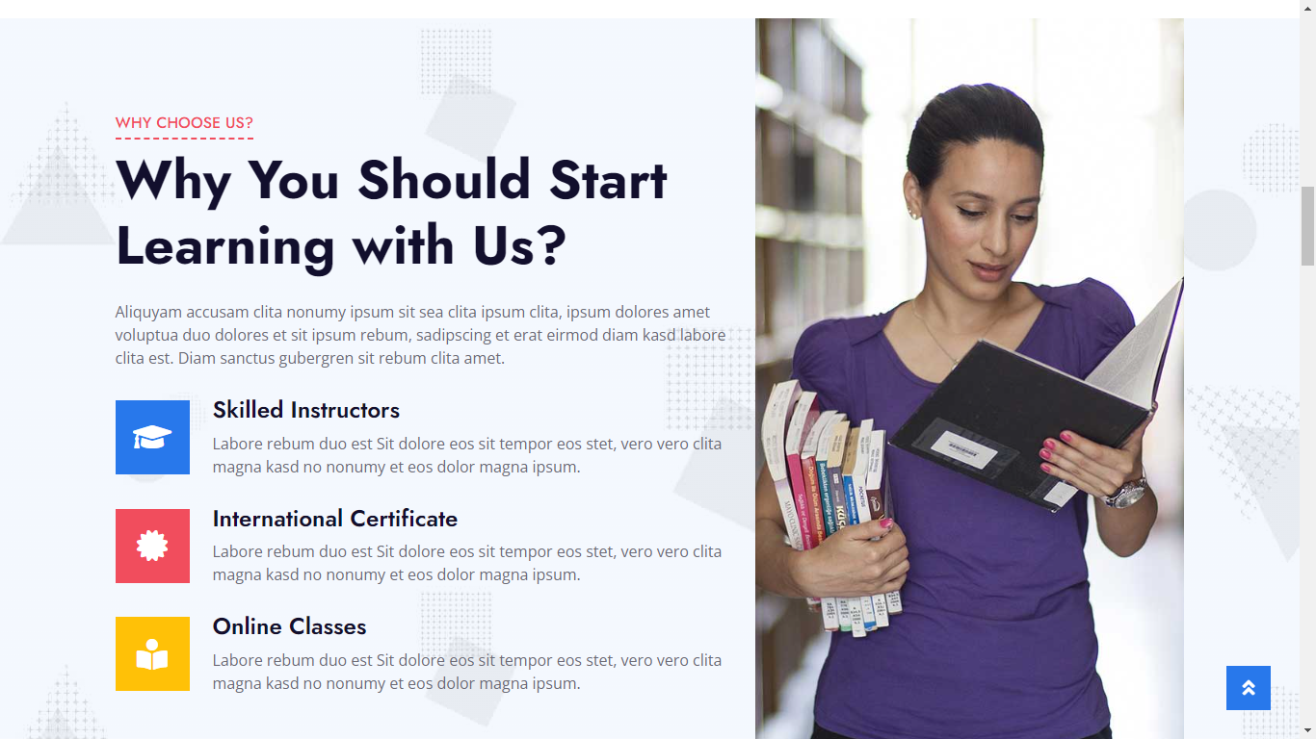 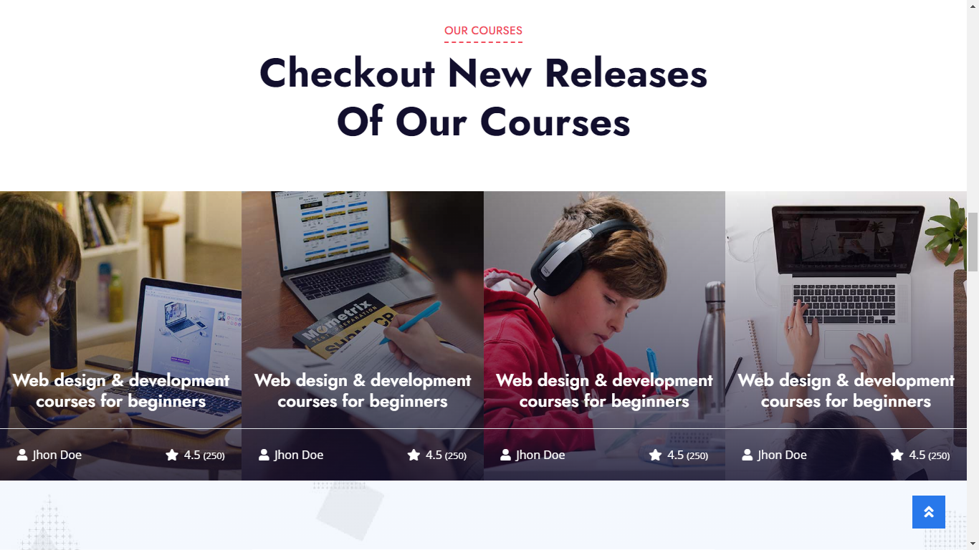 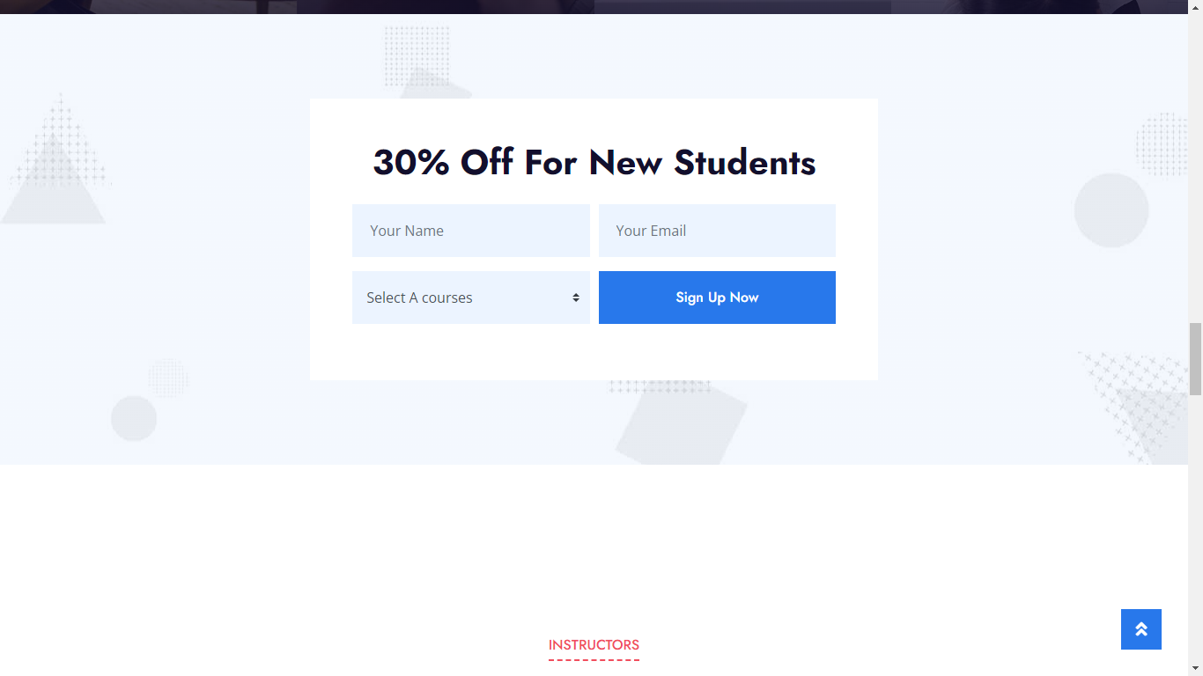 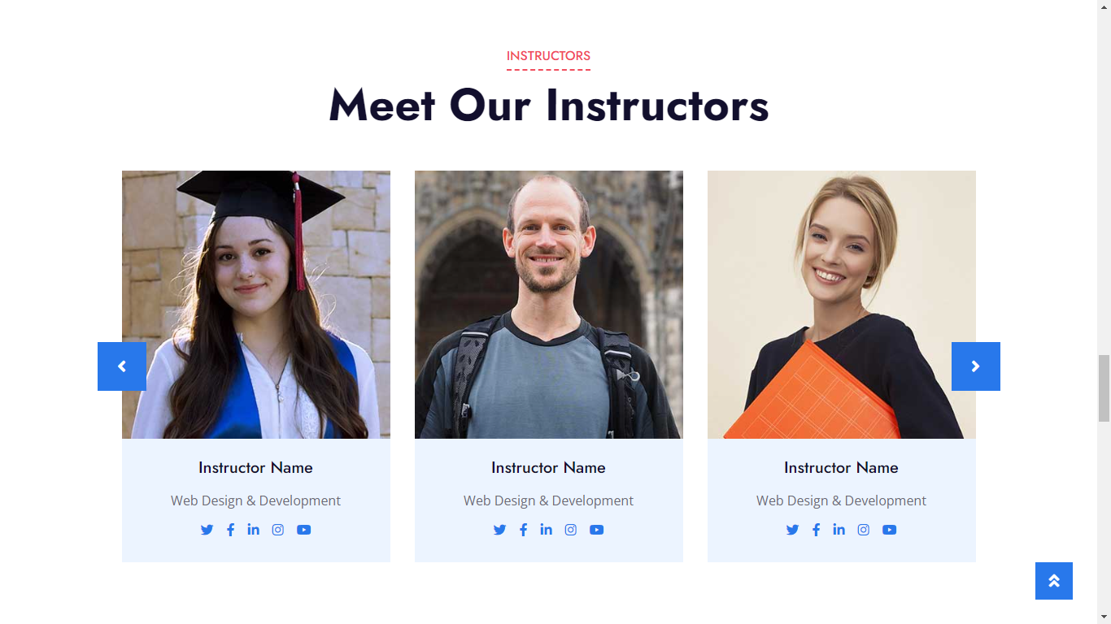 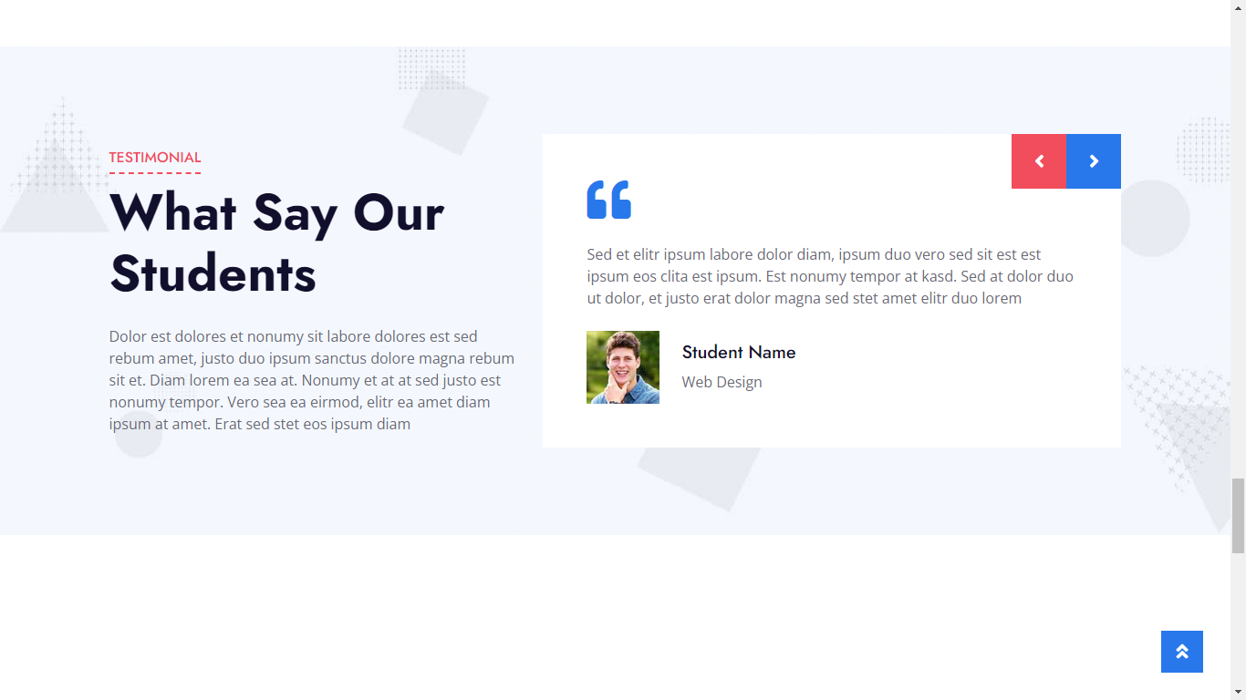 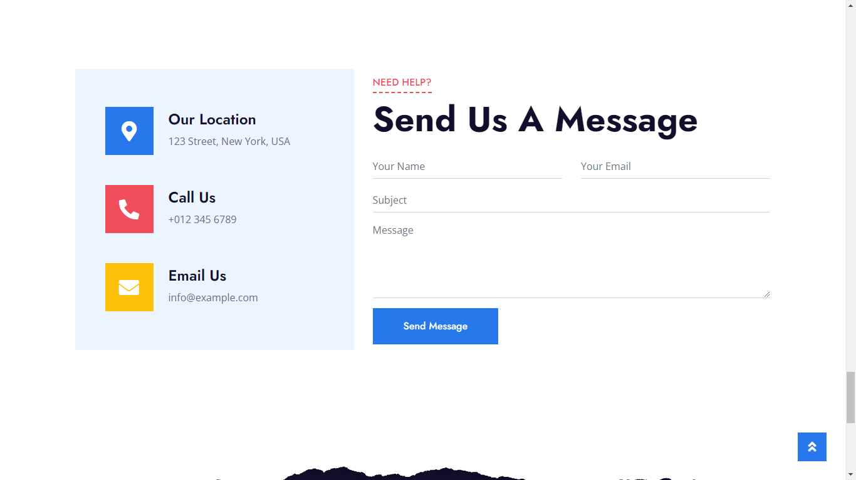 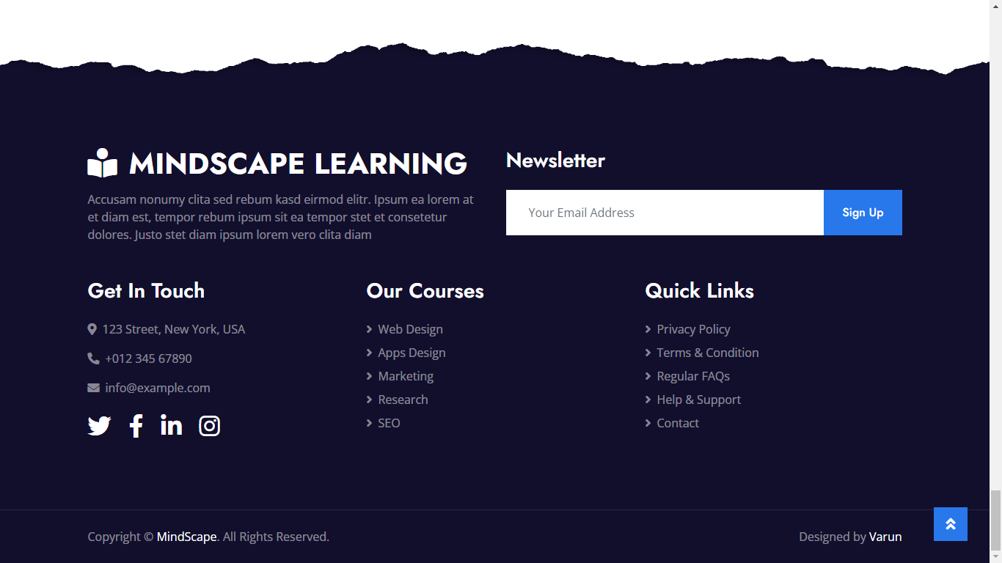

### Mobile View

